Who is the person primary person responsible for your safety?

* I am!

What is the factor/condition that contributes greatest to reduce the resistance of your skin?

* Wetness, wet skin has much less resistance.
* Keeping your skin dry is the biggest factor

What is the greatest risk from electricity (What is the worst thing that can happen)?

* Electric shock, you can die

In LabVIEW, what is a VI?

* A VI (virtual instrument) is a LabVIEW program which appears and operated imitate physical instruments. It uses functions to manipulate input the user interface and display info

What are the three main parts of the VI?

* Front panel - has the GUI/user interface
* Block Diagram – Where the program is “written”/location of graphical program
* Connector Panel – Controls all VI’s and sub VI for a program/manages all VI’s and subvi

A right click on the empty space on the front panel will display which palette?

* Controls palette

A right click on the empty space on the other window will display which palette?

* Functions palette

What palette controls the mouse functions when programming in LabVIEW?

* The tools palette

What will be displayed if you double click the broken run arrow of a LabVIEW VI?

* Info on why the program can’t run, debugging and errors menu

What are three execution control structures in LabVIEW?

* While loops, for loops and case statements

For what two functions is the program Multisim used?

* Schematic capture and simulation

How is simulation results conveyed to the Multisim user?

* The simulation results through the multisim DMM

In Multisim, can the wiper position of the potentiometer be changed while the simulation is running?

* Yes, you press “a” and you will be able to note how multimeter readings change

Where are capacitor’s leads connected to measure the capacitor’s capacitance using the ELVIS?

* At Dut + & Dut -, on side of ELVIS

What are three functions/instruments available on the ELVIS (No on eis to say the piano, flute, and guitar)?

* A DMM, a function generator, and an oscilloscope.

What are the five basic circuit components?

* Resistors, capacitors, inductors, current sources, and voltage sources.

What is Ohm’s Law?

* Ohm’s law: voltage = current \* resistance

What is Kirchhoff’s Current Law?

* The sum of all currents entering a loop = sum of currents leaving

What is Kirchhoff’s Voltage Law?

* The sum of all voltages across a closed loop is equal to 0.

What is the phase relationship between the Voltage across and the Current through a capacitor?

* There is a 90 degree phase shift, current leads.

What is the phase relationship between the voltage across the current through a resistor?

* There is no phase shift in a resistor

What is the phase relationship between the voltage across the current through an inductor?

* 90 degree phase shift, voltage leads

What is the phase relationship between the Voltage across the Current through a voltage source?

* (assumed voltage across element is what is stated, as is all elements in parallel to be 0) w/ it the current and phase adjust to what the rest of the circuit

What is the phase relationship between the voltage across and the current through a current source?

What are the 4 major parts of an Oscilloscope?

* Horizontal Axis
* Vertical Axis
* Trigger
* The Display

What are the 2 signal coupling methods on an Oscilloscope?

* AC and DC coupling

What must always be used to connect a signal into an Oscilloscope?

* An oscilloscope probe

What is the difference between the X-Y mode and Y-T mode of the oscilloscope?

X-Y plots a signal against another signal Y-T mode plots a signal against time.

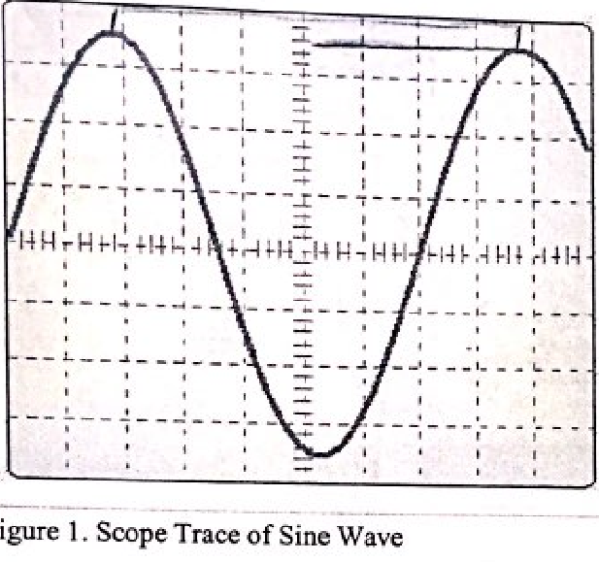

If the horizontal setting is 2 microsecond division, what is the frequency of this sine wave in figure 1?

* 7 divisions, = 7 x 2; 1/T: F = 1/0.014 approx. 71.43 Hz.

If the vertical setting is 2 millivolt/division, what is the amplitude of this sine wave in figure 1?

* (3.5)(2x10^-3) = 7mv

If the vertical setting is 5 millivolt/division, what is the amplitude of this sine wave in figure 1?

* 17.5mV

What is the value of the Peak to Peak Voltage of the sine wave in figure 1?

* Vpp = 2A = 2x7 = 14mv

What is the value of the Peak to Peak Voltage of the sine wave in figure 1?

* Vpp: 17.5 x 2 = 35mV

What will the voltage on the load be if the output impedance of the Signal Generator is set to 50 ohms, the output amplitude is set to 2 Vpp and the load impedance is 10 kOhms?

* The voltage on the load would read approx. double of what is expect. *So what is that?*

What will the voltage be on the load if the output impedance of the Signal Generator is set to High Impedance, the output amplitude is set to 2 Vpp and the load impedance is 10 kohm?

* The voltage on the load would be the expected value.

What are the three standard waveforms the Signal Generator produces?

